Anchor Bay High School Class of 2018
All proceeds to benefit the ABHS Senior All Night Party 2018

CLASS OF 2018 YARD SIGN
****only 2 orders will be placed – November 17 & March 16****
If you miss the November deadline, your order will be placed in March.
No orders will be placed after March 16th

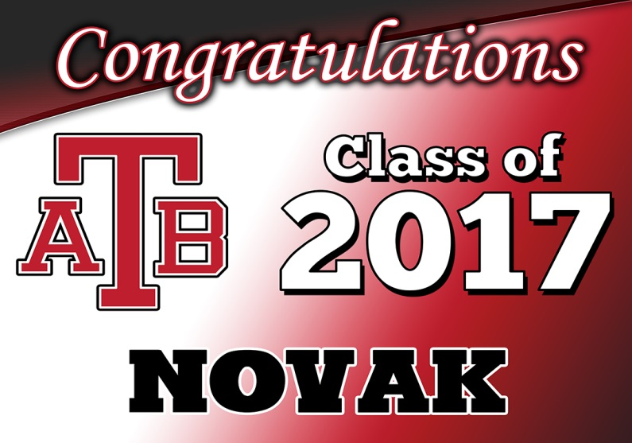
EACH SIGN IS FULL COLOR - 18” X 24”
EXAMPLE ONLY, SIGN WILL SAY 2018
$20

PLEASE PRINT IN PEN ONLY
Name of Student:__________________________________________________________________
Parent Cell Phone #:_______________________________________________________________
Parent Email:_____________________________________________________________________
**You will be emailed when the sign is ready to be picked up**
Personalization with name: (up to 15 letters maximum)

( ) Yes – Name on Sign:__________________________________________________________
*Please PRINT the name that is to go on the sign
( ) No

# of signs:___________ (EACH SIGN IS $20)

Amount included: $____________ - Payable by CASH ONLY

**ALL ORDERS SHOULD BE RETURNED TO THE STUDENT ACTIVITIES OFFICE**
QUESTIONS ABOUT THE SIGNS SHOULD BE DIRECTED TO DAWN NOVAK: 586-202-9273

